**What is Industry?**

**Industry** is:

* economic activity concerned with the processing of raw materials and manufacture of goods in factories.
* the work and processes involved in collecting raw materials, and making them into products in factories.

**Types of Industry** There are four types of industry. These are primary, secondary, tertiary and quaternary.

1. **Primary industry** involves getting raw materials e.g. mining, farming and fishing.
2. Secondary industry involves manufacturing e.g. making cars and steel.  
   Secondary industries take the raw materials produced by the primary sector and process them into manufactured goods and products.  
   Many people often find employment producing goods at home to earn a living. This form of industry is known as **cottage industry** and is also part of the secondary industry although the goods are not being produced in a factory.
3. Tertiary industries provide a service e.g. teaching and nursing.  
   The tertiary sector is also called the **service sector** and involves the selling of services and skills. They can also involve selling goods and products from primary and secondary industries.
4. Quaternary industry involves research and development industries e.g. IT.  
   The quaternary sector is sometimes included with the tertiary sector, as they are both service sectors.

***Directions: Study the pictures below carefully. Determine the form of employment illustrated and then write the type of industry on the line below.***

1.  2. 

_______________________ _____________________

1. 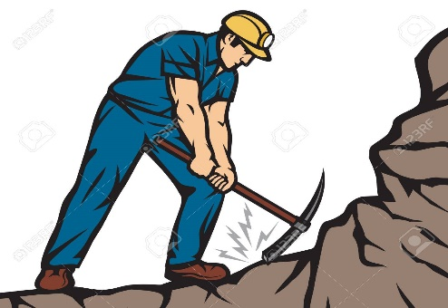 4. 

_______________________ ______________________

1.  6. 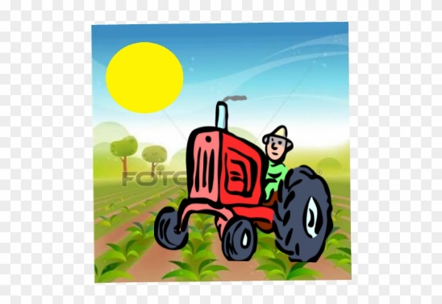

______________________ ______________________

1.  8. 

________________________ ______________________

9. 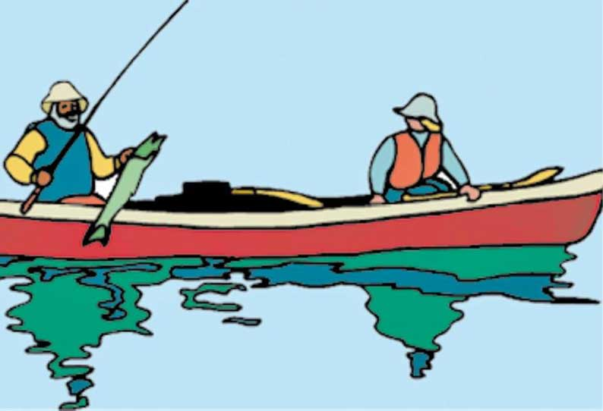 10. 

_________________________ _______________________